American Occupational Therapy Association
Occupational Therapy Curriculum Design Framework (OTCDF)
Faculty Workshop

The purpose of the OTCDF is to provide a user-friendly tool to assist occupational therapy faculty in designing programs that transform students into health professionals who are effective, influential, inclusive, collaborative, and accessible.

Workshop Objectives

By the end of this workshop, participants will:
- Learn four essential steps for designing an effective and meaningful OT/OTA curriculum.
- Reflect on the interrelated factors that influence the overall curriculum design process.
- Access helpful resources, concrete curriculum examples, and reflection questions that may be immediately applied within their own programs following the workshop.

Workshop Speakers

Amanda K. Giles, OTD, OTR/L, FAOTA  Associate Professor  Medical University of South Carolina  gilesak@musc.edu | Tiffany L. Bolton, OTD, MOT, OTR/L  Associate Clinical Professor  University of Missouri – Columbia  boltontl@health.missouri.edu

Workshop Agenda

Monday 12:30-4:00 EST  DISCUSS INFLUENTIAL FACTORS |  | Tuesday 12:30-4:00 EST  DISCUSS STEPS TO DESIGN CURRICULUM
Profession |  | Finish Step 1
Institution |  | Step 2
BREAKOUT ACTIVITY #1 |  | BREAKOUT ACTIVITY
Accreditation |  | Step 3
Teaching and Learning |  | BREAKOUT ACTIVITY
BREAKOUT ACTIVITY |  | Step 4
Students |  | BREAKOUT ACTIVITY
Society |  | Final Tips
BREAKOUT ACTIVITY
Community Partnerships
Clinical Practice
BREAKOUT ACTIVITY
Begin Step 1

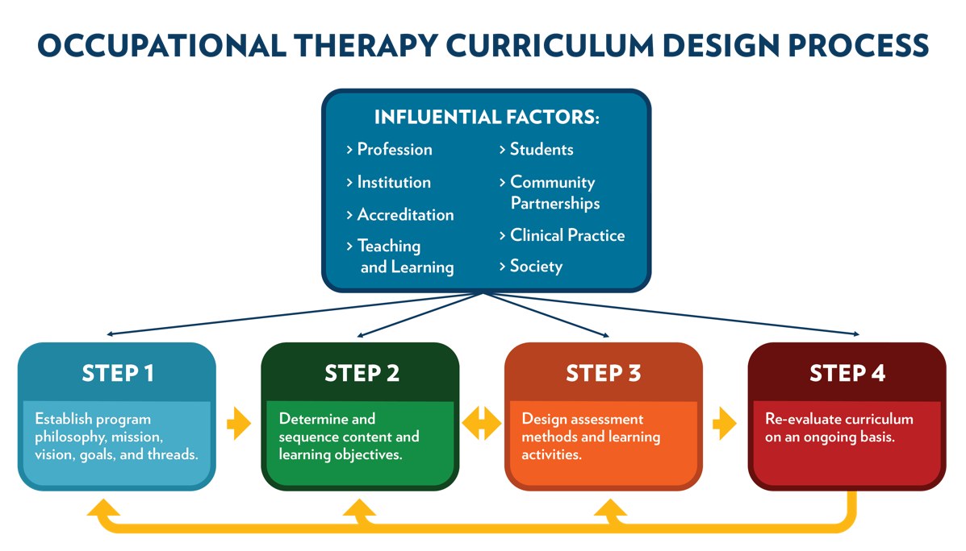

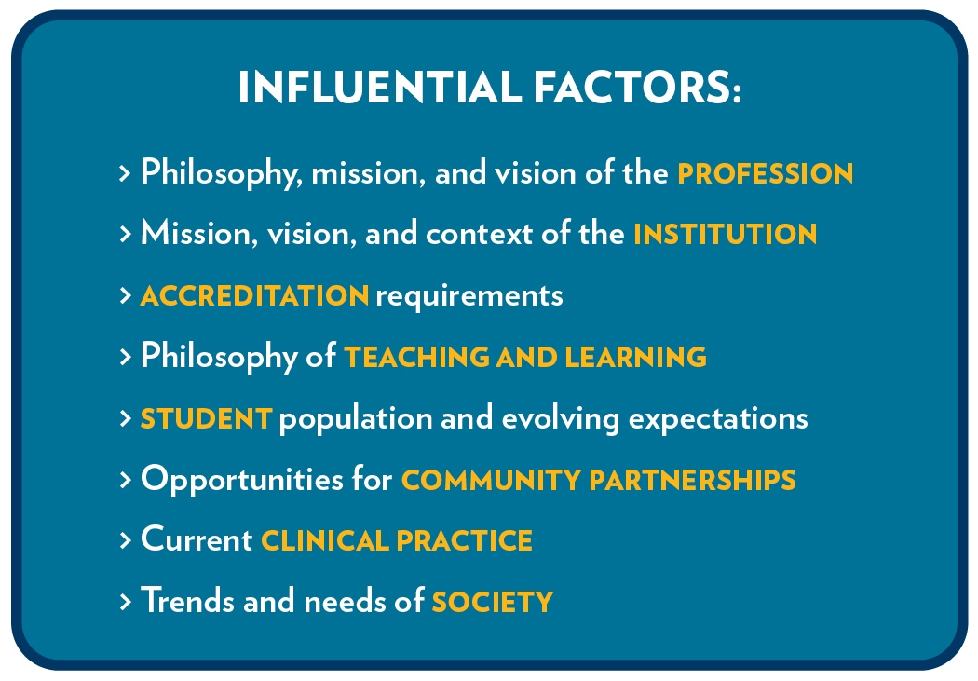

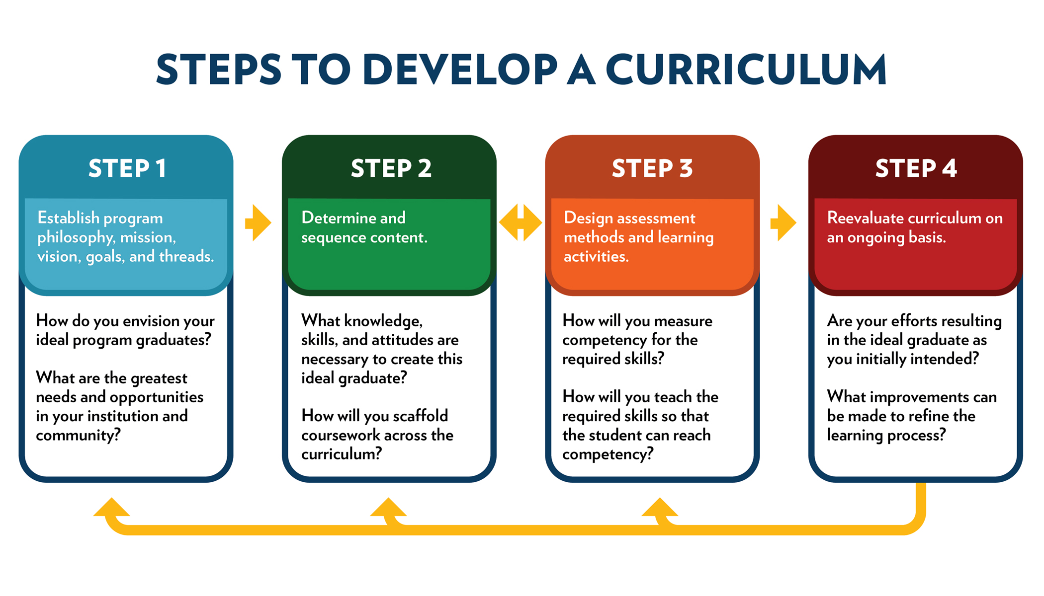

Breakout Activity #1: Congruency Between Profession and Institution
(Completed prior to workshop)

 | Profession | Institution | Program/Curriculum | Learning Activity
Philosophy | Occupations are fundamental to health
Mission | Practice, education, and research
Vision | Innate right to engage in meaningful occupations
Context | Societal needs related to participation

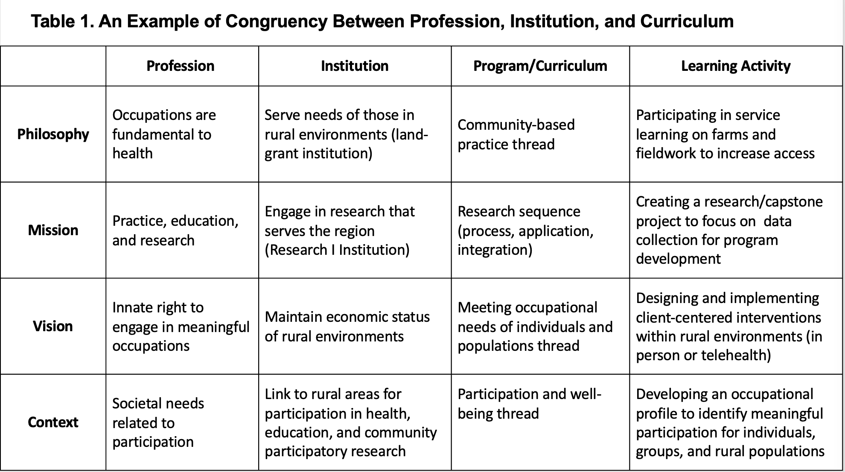
Breakout Activity #2: Educational Learning Theories

Instructions:
- Choose a theory from Appendix B.
- Share of an example of how you currently use this theory or how you could use it in future (e.g., course, activity, standard).
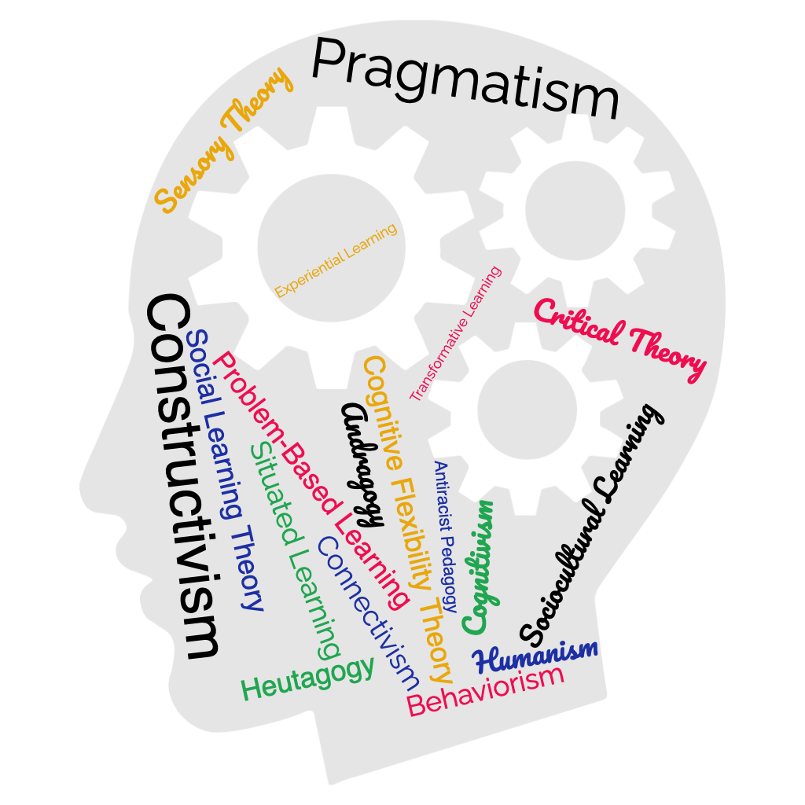
Theory:
Current or Potential Application:

Breakout Activity #3: Meeting Student and Societal Needs

Instructions:
- Using Table 2, identify strengths and challenges of meeting students’ and societal needs.
- Dialogue about effective strategies to overcome challenges.
- What else would you add to this example list of student factors?
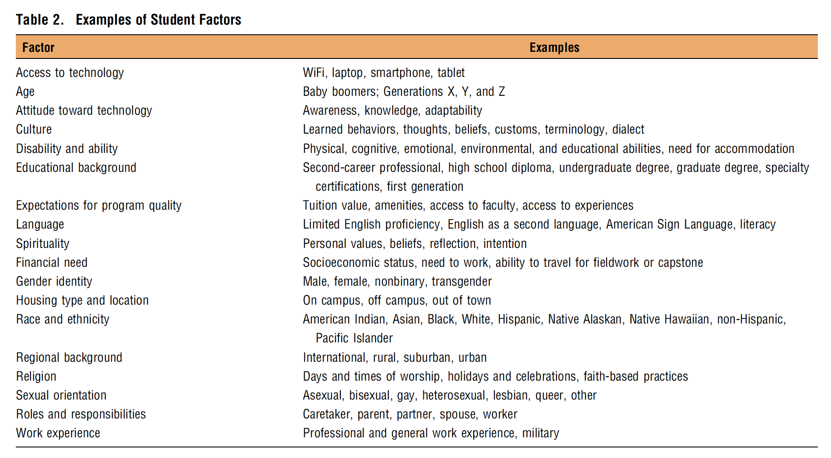
Breakout Activity #4: Connecting with Clinical Practice and Community Partners

Instructions:
Breakout room #1: Go to https://padlet.com/gilesot/workshop.

- List your challenges working with community partners/clinical practice.
- Review posts and write one or more opportunities/solutions to address a specific challenge.

Breakout Activity #5: Program Mission, Philosophy, Threads, and Goals

ACOTE Curriculum Design Template
This template is adapted for the AOTA Curriculum Workshop based on the ACOTE Curriculum Design Template located on the ACOTE website (acoteonline.org) under Forms.

2018 Standard A.5.5. Curriculum Design
“The curriculum design must reflect the mission and philosophy of both the occupational therapy program and the institution and must provide the basis for program planning, implementation, and evaluation. The design must identify curricular threads and educational goals and describe the selection of the content, scope, and sequencing of coursework. The instructional design must reflect the curriculum and ensure appropriate content delivery” (ACOTE, 2018, p. 20).

Curriculum Design
Institutional Mission:
Institutional Philosophy:
Program Mission:
Program Philosophy:
Program Philosophy of Teaching and Learning:
Program of Study (rationale for the selection, the scope and sequencing of content):
- Curricular Threads or Themes | - Goals and Objectives (Learning Outcomes) | - Course(s) that Address the Goals and Objectives | - Instructional Design¹ to Address the Goals and Objectives/Curricular Threads
Evaluation of Curriculum Design:
“A systematic analysis of formative and summative assessment occurring throughout the length of the program evaluating the selection, scope, and sequencing of content and the effectiveness in achieving student learning objectives/outcomes.”
- What do you want to know?
- How will you answer your questions?
- What do you plan to do with the information obtained?
Encompasses instructional and learning activities, methods, and materials with corresponding assessments of learning.

Breakout Activity #6: Capstone/Baccalaureate and Fieldwork

Instructions:

Discuss opportunities in your programs for integrating both capstone/baccalaureate and FW experiences across the curriculum.

Key questions:

- How will you map your curriculum so that the experiential learning enhances the didactic learning? Is the experiential learning and FW occurring in the correct sequence?

- How can capstone experiences enhance faculty scholarly activity, provide opportunities for practicum experiences, achieve program development?

- For fieldwork or capstone/baccalaureate, what is the full sequence of courses that are required before getting there? (Prerequisites, foundation, application)

Breakout Activity #7: Assessments and Learning Activities

Instructions:

Using the Curriculum Design Template as a guide (See Breakout Activity #5), think of an assessment and learning activity that supports one or more of your curriculum threads and educational goals. Share this activity within your group, including any tips/challenges for rubrics and grading.

Breakout Activity #8: Evaluating Your Program

Instructions:

Go back and review your program goals/threads…

  - How are you measuring your student learning outcomes? How will you show stakeholders that your program is doing what you said it would do? Refer to Box 8 on the next page.
  - Are your student learning outcomes reflecting your intended program goals and threads? Are you proud of your graduates? Are you satisfied with your program outcomes?
  - What will you do improve areas of weakness?

