AOTA Occupational Therapy Curriculum Design Framework Faculty Workshop • October 21, 2021

Objectives
By the end of this workshop, participants will:
- Learn four essential steps for designing an effective and meaningful OT/OTA curriculum.
- Reflect on the interrelated factors that influence the overall curriculum design process.
- Gain access to helpful resources, concrete curriculum examples, and reflection questions that may be immediately applied within their own programs following the workshop.

Agenda
Morning 8:30-12:00  DISCUSS INFLUENTIAL FACTORS |  | Afternoon 1:30-4:30  DISCUSS STEPS TO DESIGN CURRICULUM
Profession |  | Finish Step 1
Institution |  | Step 2
BREAKOUT ACTIVITY |  | BREAKOUT ACTIVITY
Accreditation |  | Step 3
Teaching and Learning |  | BREAKOUT ACTIVITY
BREAKOUT ACTIVITY |  | Step 4
Students |  | BREAKOUT ACTIVITY
Society |  | Final Tips
BREAKOUT ACTIVITY
Community Partnerships
Clinical Practice
BREAKOUT ACTIVITY
Begin Step 1
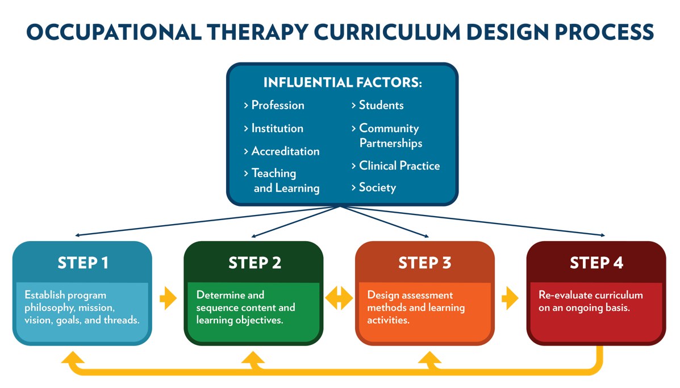

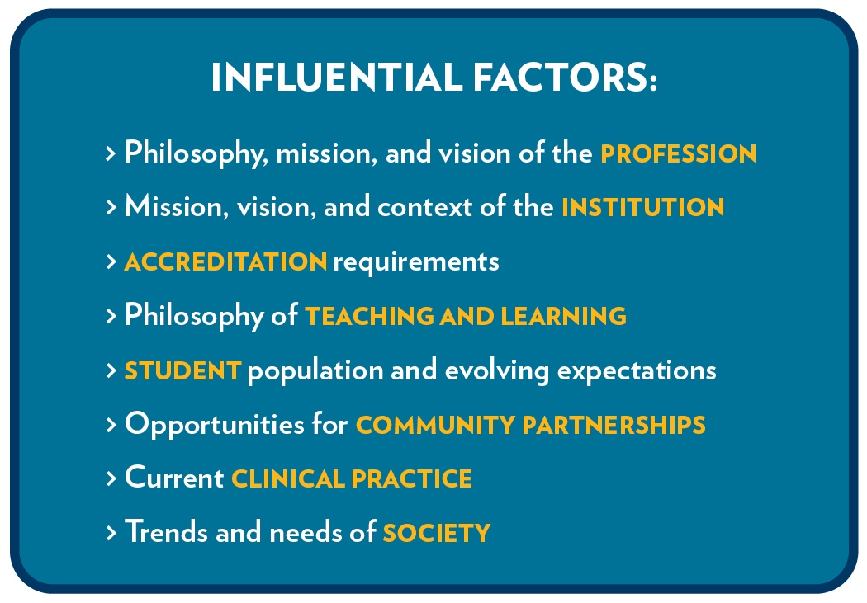

Influential Factors: Profession Breakout Activity

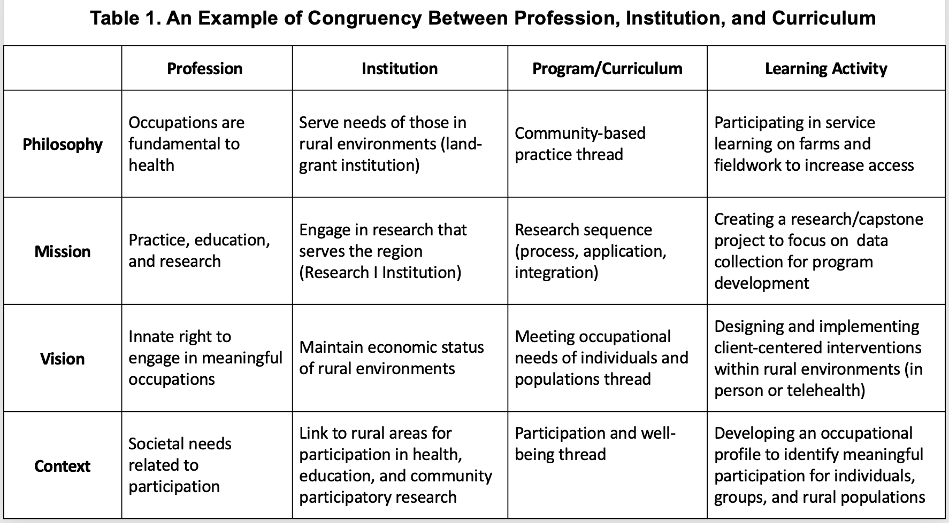
Influential Factors: Profession Breakout Activity
 | Profession | Institution | Program/Curriculum | Learning Activity
Philosophy | Occupations are fundamental to health
Mission | Practice, education, and research
Vision | Innate right to engage in meaningful occupations
Context | Societal needs related to participation

Curriculum Design Template
This template is adapted for the AOTA Curriculum Workshop based on the ACOTE Curriculum Design Template located on the ACOTE website (acoteonline.org) under Forms.

2018 Standard A.5.5. Curriculum Design
“The curriculum design must reflect the mission and philosophy of both the occupational therapy program and the institution and must provide the basis for program planning, implementation, and evaluation. The design must identify curricular threads and educational goals and describe the selection of the content, scope, and sequencing of coursework. The instructional design must reflect the curriculum and ensure appropriate content delivery” (ACOTE, 2018, p. 20).

Curriculum Design
Institutional Mission:
Institutional Philosophy:
Program Mission:
Program Vision:
Program Philosophy:
Program Philosophy of Teaching and Learning:
Curricular Threads and  Program Educational Goals | Learning Objectives | Assessment (Expectation for Demonstrating Competency) | Teaching Activities  (Method for Teaching Competency)
Curriculum Evaluation:
- What do you want to know?

- How will you answer your questions?

- What do you plan to do with the information obtained?

Influential Factors: Student and Society Breakout Activity

Purpose
To identify strengths and challenges within your own programs in meeting the needs of student populations and society. By creating a visual of these strengths and challenges, our hope is that you can dialogue with faculty about things that work well in your program and how student populations and societal needs impact your curriculum. After the conference, your visual will be a reminder to always keep learning more about the people you serve.

What to do
- Create a bracelet (or whatever shape you want!) using the pipe cleaners and beads at your table.
- Place beads on your bracelet according to the categories below.
- Once your bracelet is complete, match up with someone at your table whose bracelet is different than yours.
- Brainstorm ideas based on your program’s strengths to help each other with your program’s unique challenges.
- Be prepared to share with the group something you plan to try out when back at work!

For each segment: If you answer yes to more than 3 of the criteria (OR if you feel this is an area of strength), add 5 different colors of beads. If no (OR if you feel this is an area of challenge and would like to brainstorm), add 5 red beads.

Segment 1: Student factors
  - Gender identity other than man/woman
  - Sexual orientation other than heterosexual
  - Students with low income and/or limited academic preparation
  - Student roles/responsibilities beyond being a student (caretaker for a parent, have their own child, married, etc)
  - Students with disabilities
  - Race other than white/Caucasian
  - English as a second language
  - Religion requiring exceptions for school commitments
  - __________________________________

Segment 2: Current Program Practices: Students
  - Account for cost of tuition and supplies (make attempts to keep it low)
  - Provide access to technology/wifi
  - Provide affordable housing for school and FW
  - Use holistic admissions
  - Partake in formal training for DEI
  - Test and address hidden biases
  - Maintain cultural competency
  - Faculty are diverse
  - ____________________________

Segment 3: Meeting Society’s Needs
  - Surrounding society is diverse
  - Institution recognized as a safe space for diverse clients
  - Building/facilities are accessible
  - Institution is well-known in area for serving the underserved
  - Institution is well-known in the area for meeting a variety of relevant needs of society
  - Multiple opportunities for partnerships exist in the region
  - Institution has a service-learning office or office for community outreach
  - _______________________________

Segment 4: Current Program Practices: Society
  - Students are engaged in multiple aspects of the community
  - Makes attempts to address health literacy
  - Fieldwork sites occur in both traditional and emerging areas of practice
  - Students engage in research and/or program development directly related to areas of need in your society
  - Students and/or faculty conduct needs assessments of surrounding populations
  - Course content is tailored to specific regional needs when appropriate
  - Coursework provides opportunities for community experiences or partnerships
  - Community partnerships are developed with sustainability in mind
  - _______________________________

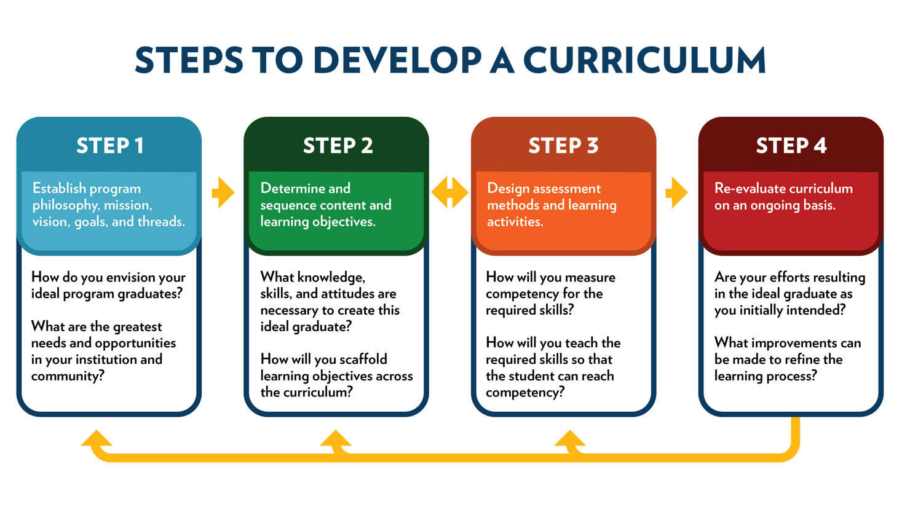Step 2 Breakout Activity

Discuss opportunities in your programs for integrating both capstone and fieldwork experiences across the curriculum.

Key points to keep in mind:

- How will the experiential learning enhance the didactic learning? Is the experiential learning and FW occurring in the correct sequence?

- How can capstone experiences enhance faculty scholarly activity, provide opportunities for practicum experiences, achieve program development?

- For any ideas you have for fieldwork or capstone, what is the full sequence of courses that are required before getting there? (prerequisites, foundation, application)

